**A FINAL REQUIREMENT PRESENTED TO**

**IT-332 : INTEGRATIVE PROGRAMMING AND TECHNOLOGIES**



SUBMITTED TO: MS. RIA L. CASTILLO

JOHN ARTHUR B. PALIS, CHRISTINE JOY M. ALANGILAN, MA. ANTONIETTE G. ATIENZA, MARIAN Z. GUERRA, MARIEL Z. GUERRA

GEAR UP

GEAR UP

**A MOBILE-BASED INVENTORY APPLICATION**



**ABSTRACT**

Nature exists in businesses and some of these are simple to manage, while others are more tough. The need for such software is rising every day, and as a result, the numerous organizations offering related services is also increasing. This proposed project seeks to develop Gear Up, a mobile-based application for managing commercial inventory systems. Also, this application will be used to manage a business with the assistance of a technology system and will allow the users to add, modify, and update items, as well as view and delete item. Furthermore, this project minimizes paper work, human errors, manual delays, and accelerates the process. The scope of this project focuses on the monitoring inventory supplies of a hardware store. To achieve the purpose, the mobile-based inventory application database records the information of the supplies present in the businesses. Inventory optimization is the process of reconciling capital investment limits and goal-achievement restrictions. As a result, this project will be able to reduce and supports sustainable inventory and safety inventory levels.

This mobile-based inventory application is essential for ensuring quality control in businesses that deal with consumer items. A large retail store may run out of stock on an important item if inventory is not regulated properly. The managers should ensure that the goods are offered appropriately and that there is always enough stock available. If the business keeps too much stock at any given time, it will be unprofitable since the cost of keeping would have been too high, diminishing profitability. The worth of revenue lost in order to purchase the stock will be excessively high, the space taken up by the stock will be enormous, and the management of that stock will be expensive. But in the other side, keeping sufficient stock at any given time will lead to a good sale. Time, economies of scale, seasonal unpredictability, and seasonal demand are all reasons why inventory should be kept.



**DESCRIPTION OF THE PROJECT**

The Gear Up Inventory Application is a real-time inventory database capable of keeping track of various products. Also, it will provide an advanced and systematic way of inventory management through a mobile-based application. This project will create an Android application for controlling mobile-based inventory items in the hardware store, which can help enhance efficiency and facilitate transaction stock levels. As a result, it can distribute optimal results in terms of speed, accuracy, and validity when performing data handling supplies. Its goal is to effectively serve the customer and intends to help the users in speeding up their work by utilizing a system that allows them to monitor the remaining products in the records that they can see in the database. Accessing information in its database will ease operations, reduce unnecessary duplication, save time, and enable staff members to oversee their time more effectively in order to enhance customer experience, thereby explicitly or implicitly achieving better revenues and profits.

**OBJECTIVES**

The general objective of the project is to develop a mobile inventory application that will help in the operation of a business.

Specifically, it is aimed to:

1. To reduce paper work, human errors, and manual inventory delays.
2. To provide a user-friendly and concise service through the use of mobile application.
3. To increase the performance and efficiency of the process in monitoring inventory.
4. To increase the accuracy of measuring and reviewing products in a business.

**APPLICATION FEATURES**



**DEVELOPMENT MODEL**

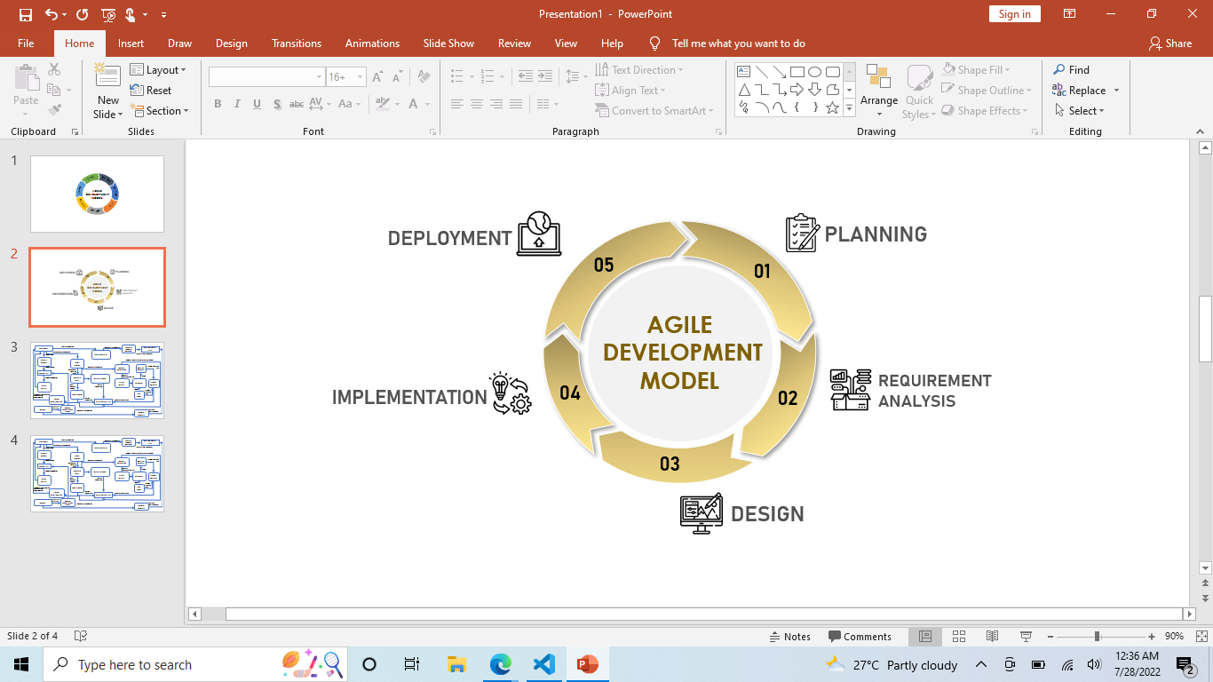

#### AGILE DEVELOPMENT MODEL

The Agile Software Development Model was used as a development model to guide system development. It served as the foundation for carrying out the various development stages, which included planning, design, development, and testing, as illustrated in the figure above. The Agile method was the most accurate project model used by the developers as a systematic procedure to achieve a specific goal.



**DEVELOPMENT MODEL**

#### PLANNING

During this phase of development, the team conducted online meetings to communicate each idea to create a concept for the project. The team also shares their suggestions through Facebook messenger to create a layout component for the project.

#### REQUIREMENT ANALYSIS

This phase is also considered as a crucial part of a software development. The team determined the requirements that is necessary for project such as, identifying the needs of the client, determining the feasibility of the needed system, and allocates the functionalities of the system. Any changes on the requirements will be documented.

#### DESIGN

The team discussed the flow of the functionalities of the systems and identifies the programming languages and software to be used. At this phase, the team also discussed the appearance of the software. The design was also revised as per advice of the instructor.

#### IMPLEMENTATION

This is the doing phase of the development. The team started the programming of the software and designed the elements and components needed. In this phase, the team works for the project to be visible to the user.

#### DEPLOYMENT

It is the final phase of the development. During this phase, the product is ready to be handed to the user. The team presented the output of the development after passing several test or evaluations.



**SYSTEM ARCHITECTURE**

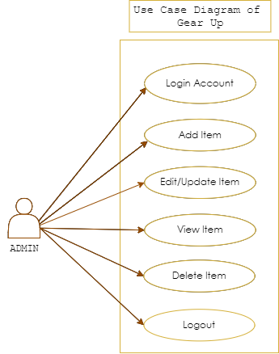

#### USE CASE DIAGRAM



**SYSTEM ARCHITECTURE**

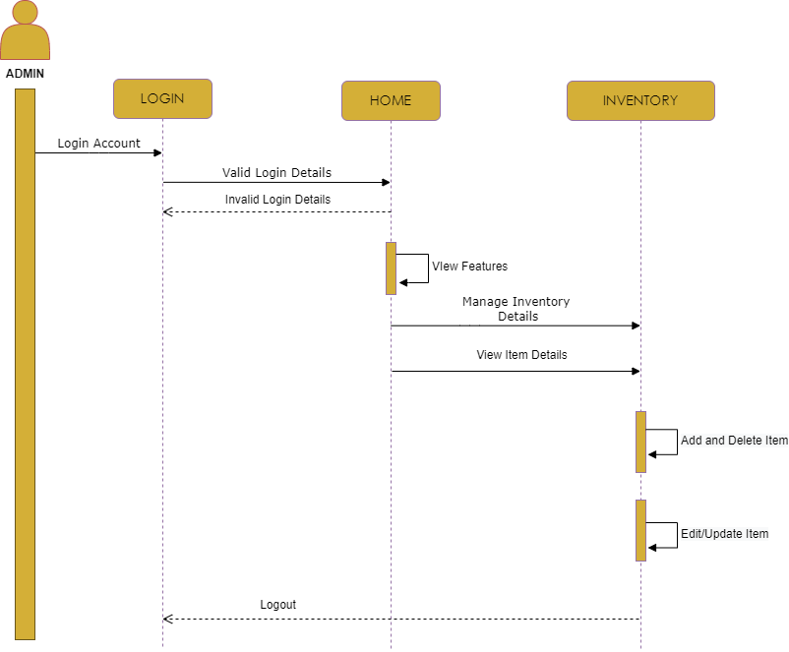

#### SEQUENCE DIAGRAM



**GITLAB REPOSITORY**

**Link to Repository:**

*https:// github. com/ marianzguerra/ App Dev_Project*



**APPLICATION SCREENSHOTS**



**TEAM MEMBERS**



# TEAM MEMBER 1

## Palis, John Arthur B.

[johnarthur.palis@g.batstate-u.edu.ph](mailto:johnarthur.palis@g.batstate-u.edu.ph)

# TEAM MEMBER 2

### Alangilan, Christine Joy M

[christinejoy.alangilan@g.batstate-u.edu.ph](mailto:christinejoy.alangilan@g.batstate-u.edu.ph)



# TEAM MEMBER 3

## Atienza, Ma. Antoniette G.

[ma.antoniette.atienza@g.batstate-u.edu.ph](mailto:ma.antoniette.atienza@g.batstate-u.edu.ph)

# TEAM MEMBER 4

### Guerra, Marian Z.

[marian.guerra@g.batstate-u.edu.ph](mailto:marian.guerra@g.batstate-u.edu.ph)



# TEAM MEMBER 5

### Guerra, Mariel Z.

[mariel.guerra@g.batstate-u.edu.ph](mailto:mariel.guerra@g.batstate-u.edu.ph)